**FINAL EXAM**

**CIS 224 – December, 2018**

**(200 points)**

**Student Name : ___Jeremy Bowne__________________________**

The project: **Plan for Student Art Display**

* Your student team of five (5) members in the Art Class has decided to put on a display of your artwork on the Mall on February 25, 2019.



* The display will be available from 9 a.m. to 3 p.m.
* About 20 pieces, both paintings and small sculptures, will be displayed.
* Setup for the display may take place on February 24, and all cleanup must be completed on February 26.

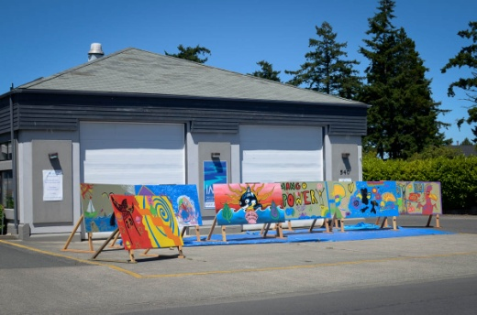

* You plan to provide printed materials (brochure) describing each piece.

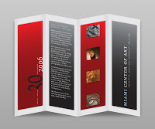

You will plan your team’s project. All materials needed for the project can be rented from GCC for $5.00 each, regardless of item (tables, chairs, easels, etc).

| **EXAM TASK** | **PTS** | **EXPLANATION OF TASK** | **PASTE SNIP OF WORK HERE.**  (Replace the sample entry in this column with your work.) |
| --- | --- | --- | --- |
| 1. Plan a detailed project, including    1. Summary Tasks    2. Detailed tasks with       1. Durations,       2. Predecessors    3. Resources, and    4. Milestones | 50 | You should enter the necessary resources, tasks, predecessors, and assignment.  When all final exam tasks are completed,   1. save your MSProject file with the name “**CIS224FinalExam.mpp**” and post it to Canvas 2. Save this Word document as “**CIS224FinaExam.docx**” and post it to Canvas | * Nothing required in this cell. * Instructor will review your mpp file for completeness. |
| 1. Create a custom calendar for at least one resource | 10 | http://cliparts101.com/files/825/AFD64395157F31A13897D771EC6F3C70/Arrow_0151.pngChoose one of your resources and assign Dec. 24 as a Non-working day. **SNIP and CIRCLE** successful accomplishment of the customization action. |  |
| 1. Assign resources to tasks | 20 | Each detail task should have at least one resource assigned. | * Nothing required in this cell. * Instructor will review your mpp file for completeness. |
| 1. Establish a “must start on” constraint for one of your detail tasks. | 10 | http://cliparts101.com/files/825/AFD64395157F31A13897D771EC6F3C70/Arrow_0151.pngChoose one of you project tasks and set the assigned constraint. Then **SNIP and CIRCLE** successful accomplishment of the result. |  |
| 1. Create an appropriate view and filter its data. | 10 | http://cliparts101.com/files/825/AFD64395157F31A13897D771EC6F3C70/Arrow_0151.pngChose any view. Apply the filter function. Then **SNIP and CIRCLE** successful accomplishment of the result. |  |
| 1. Establish a project baseline schedule. | 10 | Self-explanatory*.* Then **SNIP and CIRCLE** successful accomplishment of the result.  http://cliparts101.com/files/825/AFD64395157F31A13897D771EC6F3C70/Arrow_0151.png |  |
| 1. Add actuals (% complete) to some of your tasks to show tracking. | 20 | http://cliparts101.com/files/825/AFD64395157F31A13897D771EC6F3C70/Arrow_0151.pngMake some tasks 100% complete, and at least two tasks 50% complete. Then **SNIP and CIRCLE** successful accomplishment of the result. |  |
| 1. Add lag time to a detail task. | 10 | http://cliparts101.com/files/825/AFD64395157F31A13897D771EC6F3C70/Arrow_0151.pngChoose one of your project tasks and set **2 days of lag time**. Then **SNIP and CIRCLE** successful accomplishment of the result. |  |
| 1. Add a **WBS** column and a **COST** column to your Gantt View | 10 | Self-explanatory. **COST** column should contain non-zero values, indicating that resources have costs associated with them. Then **SNIP and CIRCLE** successful accomplishment of the result.  http://cliparts101.com/files/825/AFD64395157F31A13897D771EC6F3C70/Arrow_0151.png |  |
| 1. Create a custom view | 15 | http://cliparts101.com/files/825/AFD64395157F31A13897D771EC6F3C70/Arrow_0151.pngCreate a simple custom view and give it a name. Then **SNIP and CIRCLE** successful accomplishment of the result. |  |
| 1. Display the Project statistics | 10 | http://cliparts101.com/files/825/AFD64395157F31A13897D771EC6F3C70/Arrow_0151.pngGet the project information to see a summary of status to-date. Then **SNIP and CIRCLE** the “Percent complete” values. |  |
| 1. Create a report. | 15 | http://cliparts101.com/files/825/AFD64395157F31A13897D771EC6F3C70/Arrow_0151.pngChoose and create a **visual** report – it will be graphical in nature. The specific report is up to you. Then **SNIP and CIRCLE** successful accomplishment of the result. |  |
| 1. Export your MS Project to Excel | 10 | Save your Excel file with the name “**CIS224FinalExam.xlsx**” and post it to Canvas. | Nothing required in this cell. |